Internet Issue:

Vim /etc/resolv.conf 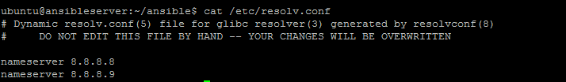

Installation steps

sudo apt-get update

sudo apt-get install software-properties-common

sudo apt-add-repository ppa:ansible/ansible

sudo apt-get update

sudo apt-get install ansible

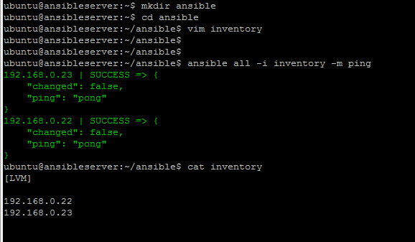

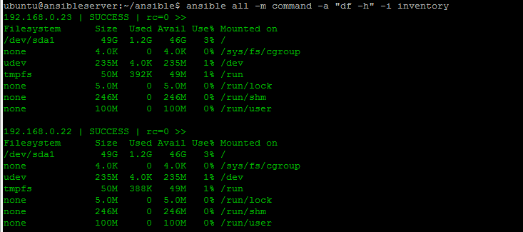

Vim /etc/sudoers

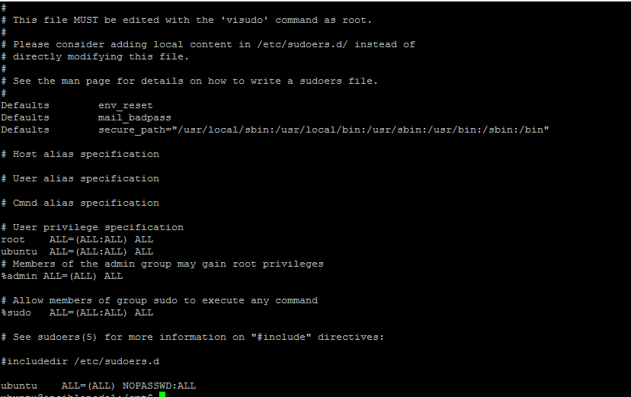

ubuntu@ansibleserver:~/ansible/playbooks$ cat lvm.yaml

#Creating the Directory for LVM Mount point

- hosts: all

sudo: True

tasks:

- name: creating Directory for LVM Mount Point

action: file path=/opt/app state=directory

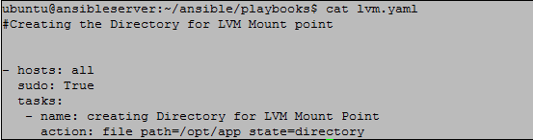

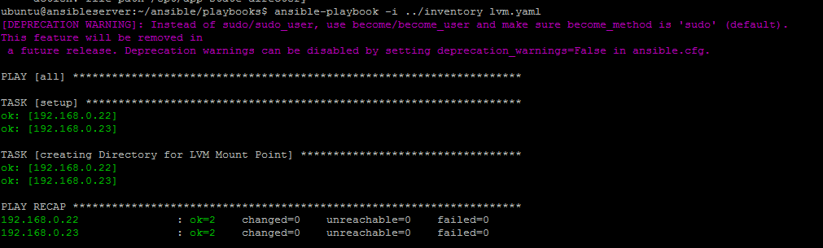

Fdisk /dev/sdb

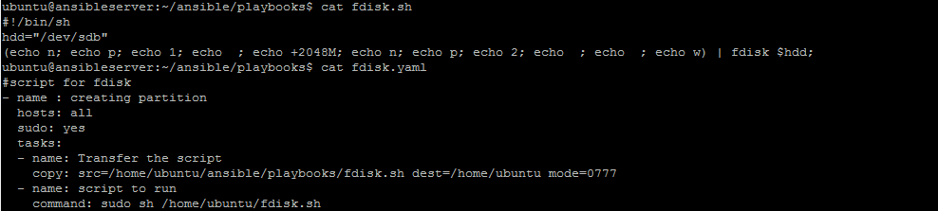

ubuntu@ansibleserver:~/ansible/playbooks$ cat fdisk.sh

#!/bin/sh

hdd="/dev/sdb"

(echo n; echo p; echo 1; echo ; echo +2048M; echo n; echo p; echo 2; echo ; echo ; echo w) | fdisk $hdd;

ubuntu@ansibleserver:~/ansible/playbooks$ cat fdisk.yaml

#script for fdisk

- name : creating partition

hosts: all

sudo: yes

tasks:

- name: Transfer the script

copy: src=/home/ubuntu/ansible/playbooks/fdisk.sh dest=/home/ubuntu mode=0777

- name: script to run

command: sudo sh /home/ubuntu/fdisk.sh

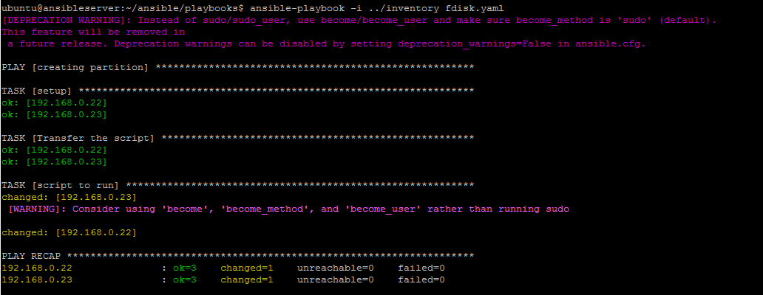

Installing lvm package

#installing lvm package

- name: Install the package "lvm2"

apt:

name: lvm2

state: present

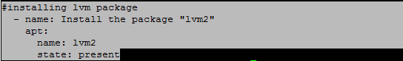

ubuntu@ansibleserver:~/ansible$ cat /home/ubuntu/ansible/playbooks/lvm_create.sh

#!/bin/sh

# Script to create a physical volume in LVM

echo "enter the devices to create the physical volume"

pvcreate /dev/sdb1 /dev/sdb2

echo "following confirms the pv is created"

pvs

#!/bin/sh

# Script to create a vg in LVM

echo "enter the volume group name followed by the devices to create the volume group "

vgcreate vg1 /dev/sdb1 /dev/sdb2

echo "following confirms the volume group is created"

vgs

#!/bin/sh

# Script to create the logical volume in LVM

echo "enter the size followed by the LV and VG name to create the logical volume "

lvcreate -L +20G -n lv1 vg1

echo "following confirms the logical volume is created"

lvs

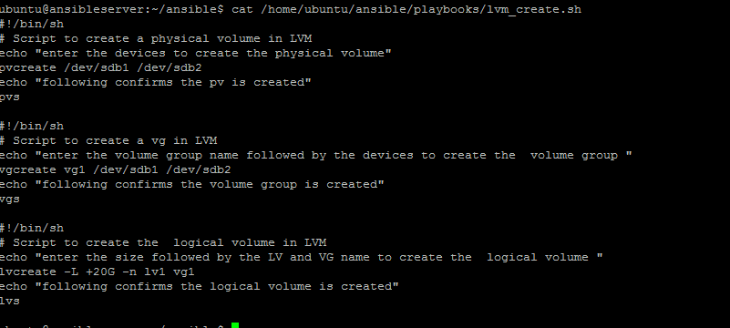

ubuntu@ansibleserver:~/ansible/playbooks$ cat mkfs.yaml

#making filesyste

- hosts: all

sudo: True

tasks:

- filesystem:

fstype: ext4

dev: /dev/vg1/lv1

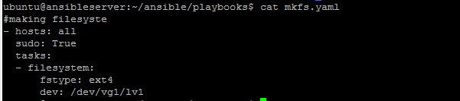

ubuntu@ansibleserver:~/ansible/playbooks$ cat /home/ubuntu/ansible/playbooks/mountpnt.sh

#creating mountpoint

echo "/dev/mapper/vg1-lv1 /opt/app ext4 defaults 0 0" >> /etc/fstab;

mount -a;

df –h

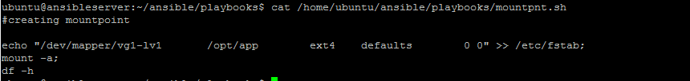

Last final script

ubuntu@ansibleserver:~/ansible/playbooks$ cat mkfs.yaml

#making filesyste

- hosts: all

sudo: True

tasks:

- filesystem:

fstype: ext4

dev: /dev/vg1/lv1

ubuntu@ansibleserver:~/ansible/playbooks$ cat /home/ubuntu/ansible/playbooks/mountpnt.sh

#creating mountpoint

echo "/dev/mapper/vg1-lv1 /opt/app ext4 defaults 0 0" >> /etc/fstab;

mount -a;

df -h

ubuntu@ansibleserver:~/ansible/playbooks$ cat orginal/lvm.yaml

#Creating the Directory for LVM Mount point

- hosts: all

sudo: True

tasks:

- name: creating Directory for LVM Mount Point

action: file path=/opt/app state=directory

#script for fdisk

- name : creating partition

hosts: all

sudo: yes

tasks:

- name: Transfer the script

copy: src=/home/ubuntu/ansible/playbooks/fdisk.sh dest=/home/ubuntu mode=0777

- name: script to run

command: sudo sh /home/ubuntu/fdisk.sh

#installing lvm package

- name: Install the package "lvm2"

apt:

name: lvm2

state: present

#script for creating LVM

- name: Transfer the script

copy: src=/home/ubuntu/ansible/playbooks/lvm_create.sh dest=/home/ubuntu mode=0777

- name: script to run

command: sudo sh /home/ubuntu/lvm_create.sh

#making filesystem

- filesystem:

fstype: ext4

dev: /dev/vg1/lv1

#fstab entry and create mount point

- name: fstab entry and create mount point

hosts: all

sudo: yes

tasks:

- name: Transfer the script

copy: src=/home/ubuntu/ansible/playbooks/mountpnt.sh dest=/home/ubuntu mode=0777

- name: script to run

command: sudo sh /home/ubuntu/mountpnt.sh